RTX Corporation (RTX) Visual Equity Report
AXIOM-inspired structure: stronger alert, three-paragraph executive summary, and company snapshot without the bloat.
VERITAS ALERT: RTX closed at $174.26 on 2026-04-24. It is trading below the 200-day moving average, with 20-day / 50-day / 200-day levels at $193.88 / $199.09 / $178.08. Current status: DO NOT DEPLOY. Price is below all three key moving averages and the technical structure has not yet repaired.

1. Executive Summary
RTX Corporation remains a serious large-cap public company with real scale, institutional sponsorship, and durable business relevance in Industrials / Aerospace & Defense. Analyst context remains constructive, with a mean target of $215.06, an analyst count of 22, and a rating of 2.1 - Buy. The business is not the problem. The decision problem is price, timing, and setup quality.
At the market level, RTX closed at $174.26, about -18.8% below the 52-week high, with recent support near $174.26 and resistance near $203.48. The stock is below the 20-day, below the 50-day, and below the 200-day moving average. That is why the current stance is not driven by admiration for the company, but by respect for the chart.
Bottom line: the name stays in active coverage, but capital deployment should remain disciplined until structure improves. The report core is therefore built to show three things clearly: what the company is, where the stock stands now, and why the current verdict is DO NOT DEPLOY rather than active deployment.

2. Company Snapshot
Metric | Value
Ticker | RTX (NYSE)
Full name | RTX Corporation
Sector / industry | Industrials / Aerospace & Defense
Market cap | $234.7B
Enterprise value | $268.5B
Employees | 180,000
Dividend yield | 1.6%
Analyst rating | 2.1 - Buy
Consensus target | $215.06
Current status | DO NOT DEPLOY

3. Visual Snapshot
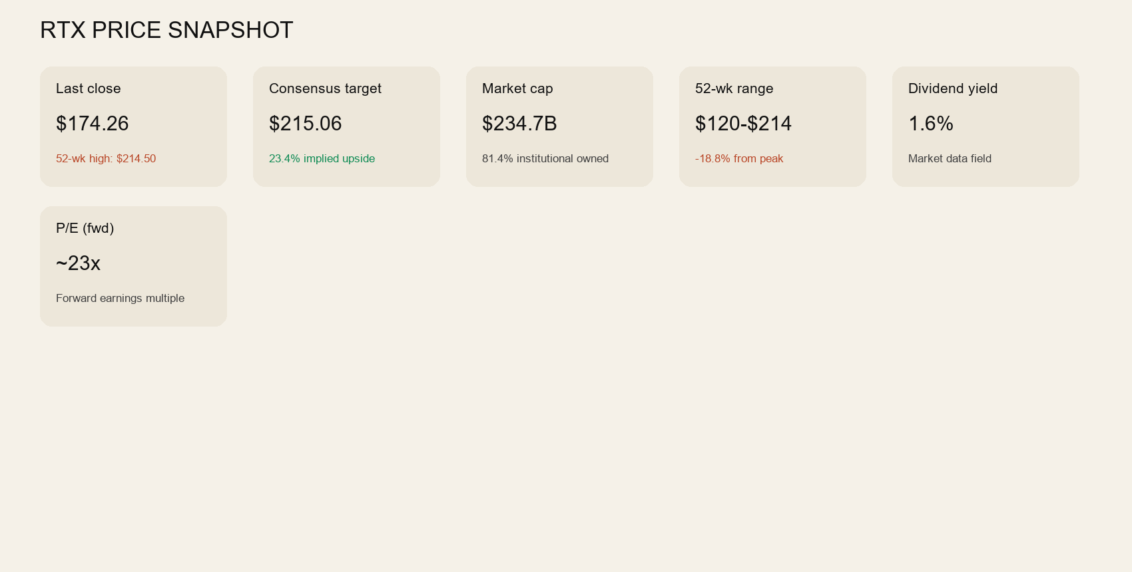

4. Historical Trend
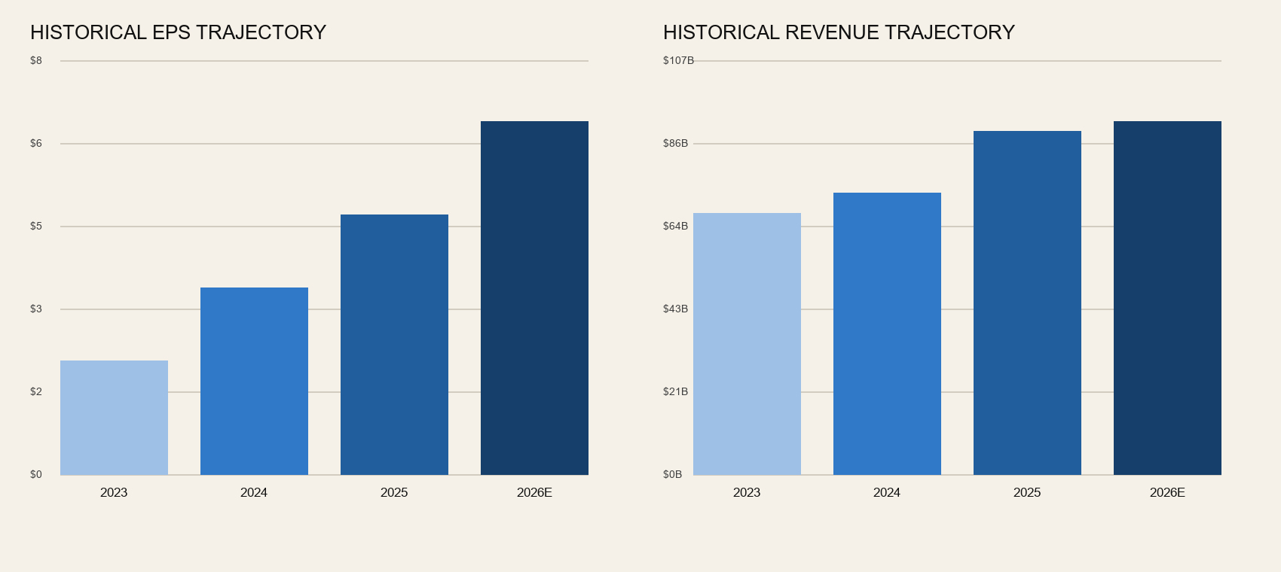

5. Valuation and Quality Metrics
Metric | Value
Revenue | $90.4B
Free cash flow | $7.2B
Operating cash flow | $11.1B
Trailing P/E | 32.7
Forward P/E | 23.1
Price / Sales | 2.60
Price / Book | 3.59
Profit margin | 8.0%
Operating margin | 13.2%
ROE | 11.6%
Current ratio | 1.02
Quick ratio | 0.65

6. Analyst Context
Metric | Value
Consensus target | $215.06
Median target | $222.50
Target range | $179.00 to $242.00
Rating | 2.1 - Buy
Recommendation | Buy
Analyst count | 22

7. Action View
Verdict: DO NOT DEPLOY. Price is below all three key moving averages and the technical structure has not yet repaired. A future upgrade would require clearer technical repair, better trend posture, and a more explicit risk-defined entry setup.

